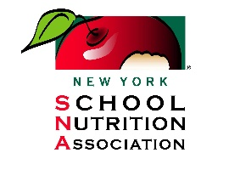**Farm to School Partnership Awards Application**

**Due on or before July 1st each year**

E-mail Completed Submissions To: [jennifer@nyschoolnutrition.org](mailto:jennifer@nyschoolnutrition.org)

**District or School Name:** ____________________________________________________________________

**Person Submitting Application:** ______________________________________________________________

**Phone:** _____________________________________ **Email:** _______________________________________

The Farm to School Partnership Award was created in partnership between the New York School Nutrition Association and New York State Department of Agriculture & Markets. This award highlights exemplary farm to school projects across New York State. Applications are reviewed by the New York School Nutrition Association and New York State Department of Agriculture & Markets. Up to four awards will be selected each year to receive this prestigious award at the New York School Nutrition Association Annual Conference.

Ideas for projects include: merchandising/promoting local foods, working with local farms, building partnerships and integrating farm to school into wellness activities, and distribution: finding creative ways to get or receive local farm products.

**Written application not to exceed 3 pages Times New Roman 12- Point Font. Project summary and response to each question is required. Attach photos or video to the e-mail or in a separate word document.**

**Content To Be Included:**

Project Summary: Please provide a summary of your farm to school project.

Question #1: Transferability: How is the project able to be replicated in other districts or areas?

Question #2: Impact/Measurability: who and how did the submission impact the children, schools, farms and/or communities?

Question #3: Innovation: How does the project show improved and creative ways to use local farm products?

Question #4: Sustainability: Explain how activity is something that can be completed every year or demonstrate growth from one year to the next.